



1. Document Revisions

|  |  |  |  |
| --- | --- | --- | --- |
| **Date** | **Version Number** | **Editor** | **Document Changes** |
| 12/29/2017 | 1.0 | JWagoner | Document Created |
|  |  |  |  |
|  |  |  |  |
|  |  |  |  |
|  |  |  |  |
|  |  |  |  |
|  |  |  |  |

1. Contents

**1** **As-Is Current Process 3**

1.1 As-Is Current Process Description 3

1.1.1 As-Is Process Diagram 3

**2** **To-Be Future Process 4**

2.1 To-Be Future Process Description 4

2.1.1 Scenario 1 4

2.1.2 Scenario 2 5

2.1.3 Scenario 3 6

2.1.4 Scenario 4 7

# As-Is Current Process

## As-Is Current Process Description

Currently, when an ‘Estimate’ has been ‘Booked’ and the Move Information has been synced between IGC and JIM, a notification is sent to JK’s Booker. The As-Is Process requires the Booker to review the Move Information and manually update the Move Status from ‘Estimate’ to ‘Pending.’ Once the Move Status has been updated to ‘Pending,’ the service activities are created via JIM’s Service Activity Center (SAC). Once the service activities have been created, the Move Status is updated to ‘Booked.’

### As-Is Process Diagram

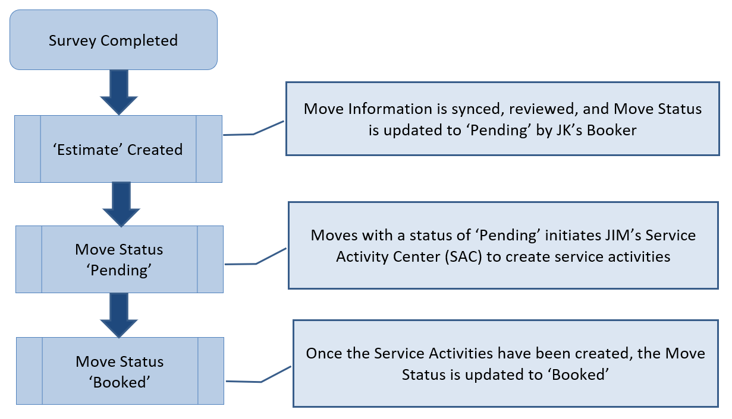

# To-Be Future Process

## To-Be Future Process Description

Through the initial phases of the Mobile App, customers will not be required to use the app and the As-Is Current Process will remain available to the customer until otherwise instructed by the business stakeholders.

The following business scenarios will be considered. Please note that the ‘Estimate Review Process’ is not detailed in this document. However, if during the ‘Estimate Review Process,’ any change in Service is requested by the Customer, the Sales Representative is required to create a new Estimate.

### Scenario 1

Estimate is selected, deposit is paid, and the Customer acknowledges and accepts the terms of their selected Move through the app. Changes and/or edits are not requested throughout the process in this scenario.

#### To-Be Future Process Diagram

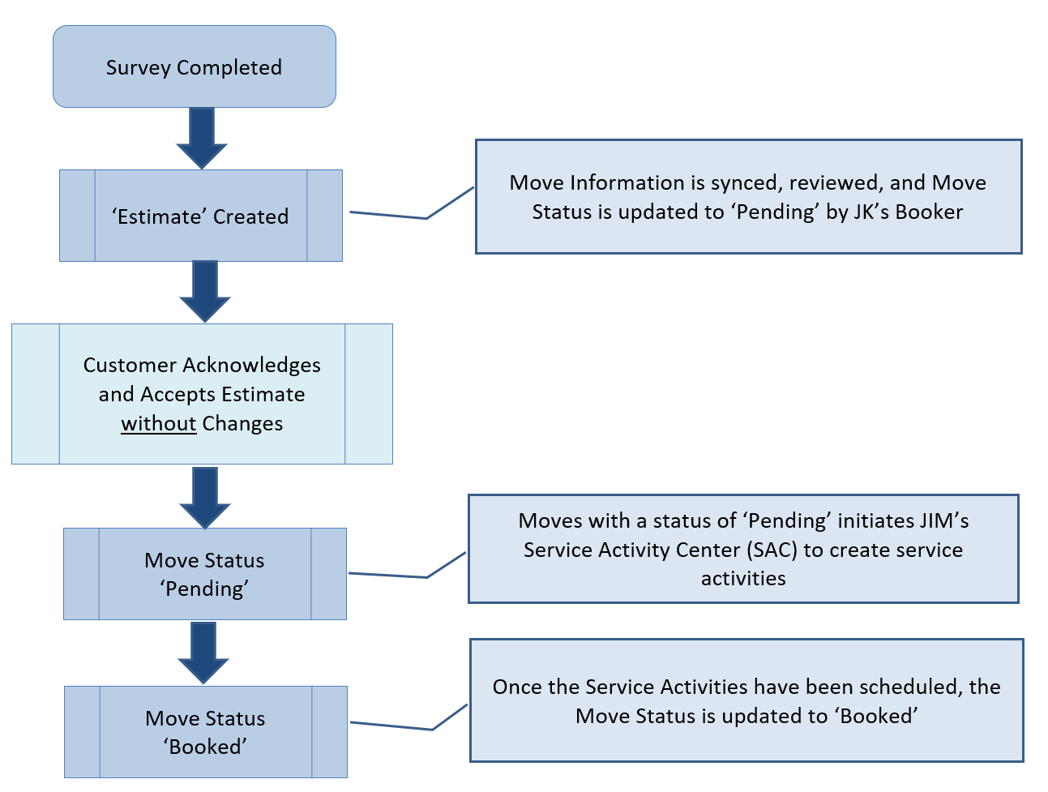

### Scenario 2

Estimate is selected, deposit is paid, and the Customer does not either fully or partially acknowledge and/or accept the terms of their selected Move through the app. Changes and/or edits are requested at some point throughout the process.

#### To-Be Future Process Diagram

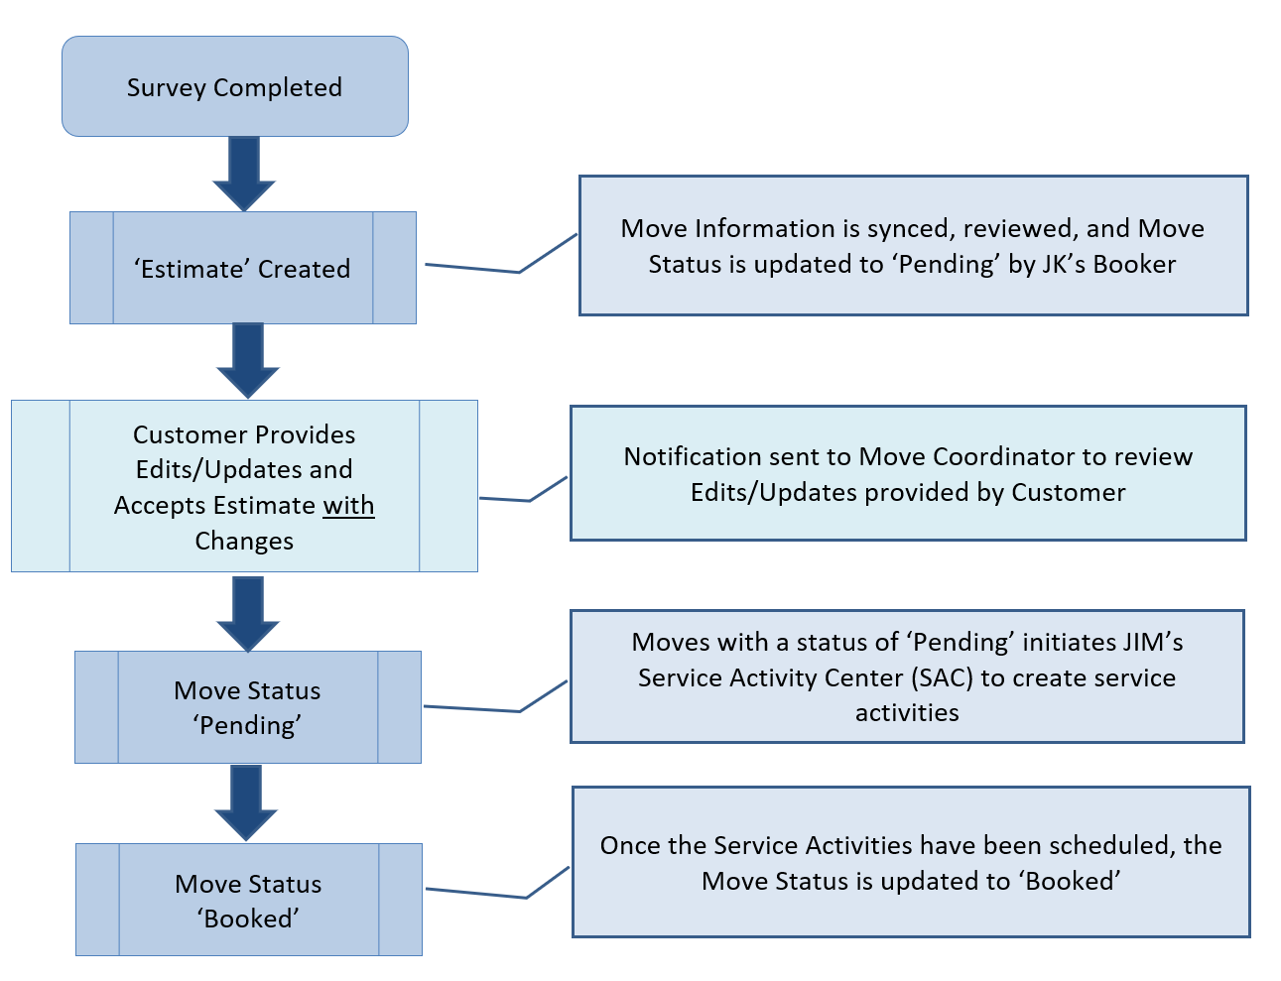

### Scenario 3

Estimate is available and pending Customer selection, Move Acknowledgement and Terms are needed, and deposit is required. Changes and/or edits are not requested throughout the process in this scenario.

#### To-Be Future Process Diagram

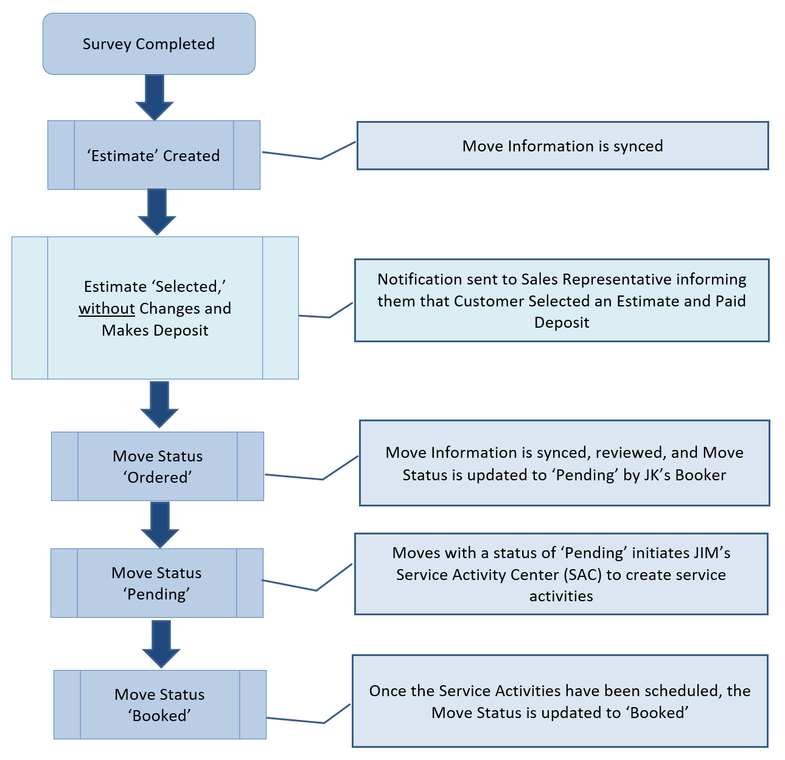

### Scenario 4

Estimate is available and pending Customer selection and the Customer does not either fully or partially acknowledge and/or accept the terms of their selected Move through the app. Changes and/or edits are requested at some point through the process.

#### To-Be Future Process Diagram

